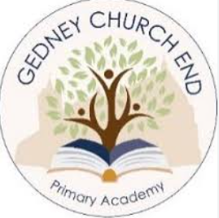

Our Art Curriculum
Our world is an increasingly visually orientated one, and our art lessons aim to provide our learners with both a way to explore the world around them and a means by which they can express their ideas and process their thoughts. It is an important form of cultural identity and therefore, has significance and meaning for all learners.
At Gedney Church End Primary Academy, our art curriculum is designed to provide learners with a range hands-on experiences, which are divided into skill areas: drawing, painting, collage, textiles, 3D design, printmaking, and digital media. Throughout their primary school art journey, our learners will be presented with opportunities to use relevant materials, processes, techniques, and vocabulary to explore and discover first-hand the potential of different media and methods. Learners explore how artists use the elements of art to create an effect and to help convey their intent and how artists and designers have helped shape our history Furthermore, they will subtly develop increased control of a range of art tools and materials. Through our teaching of art, we aim to seek a balance between learners using art as a form of personal imaginative expression and discovering the more formal elements of art.
In KS1, learners are first introduced to the latter, i.e. the use of line, shape, tone, texture and colour, which are then revisited and further built upon throughout the remainder of their primary art journey. and beyond.
We ensure that high-quality teaching drives high-quality learning through regular assessment for learning which ensures no child is left behind.

