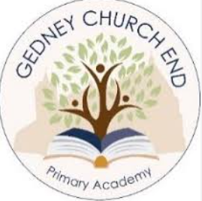

Our Geography Curriculum
At Gedney Church End Primary Academy, we believe that Geography helps our learners to develop a greater understanding of the world around them, as well as their place within it.
We aim to inspire our learners and instil curiosity and fascination about the world and its people that will remain with them for the rest of their lives. The curriculum is designed to ensure that teaching equips learners with knowledge about diverse places, people, resources and natural and human environments, together with a deep understanding of the Earth’s key physical and human processes.
As learners progress through the school, their growing knowledge about the world helps them to deepen their understanding of the interaction between physical and human processes, and of the formation and use of landscapes and environments.
The geographical knowledge and skills taught are progressive and are sequenced in such a way as to provide the framework and approaches that provide learners with an explanation of how the Earth’ s features are shaped, interconnected and change over time.
When learners leave Gedney Church End Primary Academy, they will have a deep understanding about how we differ to other locations in the world and why.

