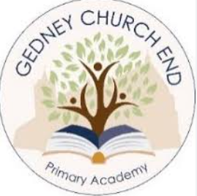

Our Music Curriculum
At Gedney Church End Primary Academy we make music an enjoyable learning experience for all learners. We encourage all learners to participate in a variety of musical experiences through which we aim to build up their love of music, self- confidence and sense of achievement.
During their primary school journey, we promote the importance of music by encouraging our learners to perform in public, at local community events as well as larger scale events such as: Young Voices.
The core concepts we seek to develop in our learners through our Music teaching are:
Singing: To improve learners’ internalisation of music through high-quality singing and listening.
Incorporate technology: To use technology to promote creativity and widen inclusion. Playing music: To know how to read music, interpret performance directions (dynamics, tempo, and style) and to perform to an audience.
Composing music: To know how to respond to a stimulus to create music, improvise around a given scale or chord sequence and arrange music.
Listening and Analysing Music: To know how music has changed over time, learning about the ‘great composers’ and their works, developing the ability to pick out key elements of music through listening.

