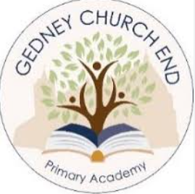

Our RE Curriculum
Religious Education has a significant role for the development of learners’ spiritual, moral, social and cultural development. It promotes respect and open-mindedness towards others with different faiths and beliefs and encourages learners to develop their sense of identity and belonging through self-awareness and reflection.
The principle aim of RE is to engage learners in an enquiry approach where they can develop an understanding and appreciation for the expression of beliefs, cultural practices and influence of principle religions and worldviews in the local, national and wider global community.
Our teaching is based on the Lincolnshire Agreed Syllabus, we acknowledge this sensitive aspect of education and realise the need for a sincere and sympathetic approach to all religions. We are aware some learners, parents and staff may hold deep beliefs whilst others hold none. With this in mind we encourage questioning and discussion but respect the right of any individual who does not want to share their inner thoughts.
The aim of the Lincolnshire Agreed Syllabus is to empower learners to be religiously literate and able to hold balanced and informed conversations about religion and belief'. We follow the advice of the agreed syllabus that 'if RE is to be made relevant and meaningful to children whether religious or not, it needs to connect with aspects of their own and other peoples experience that may be termed spiritual.'
Learners should develop key skills in order to enhance learning which should be evident across key stages. It is these skills that form the basis of our progression grid.

